

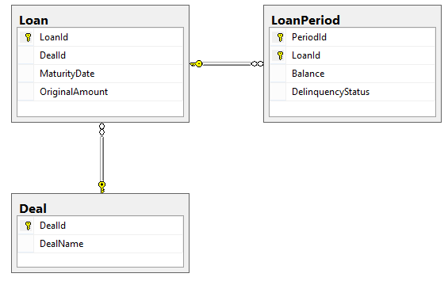

|  |  |
| --- | --- |
| SELECT * FROM Deal  **DealId DealName**  1 SQ101  2 SQ131  3 SQ132 | SELECT * FROM Loan  **LoanId DealId MaturityDate OriginalAmount**  1 1 2026-07-01 243546.00  2 1 2031-02-01 465764.00  3 1 2035-03-01 354657.00  4 1 2029-06-01 645342.00  5 1 2027-11-01 534231.00  6 2 2034-12-01 523421.00  7 2 2033-11-01 445231.00  8 2 2037-09-01 601201.00 |
| SELECT * FROM LoanPeriod  **PeriodId LoanId Balance DelinquencyStatus**  1 1 241844.00 0  1 2 463521.00 0  1 3 352657.00 0  1 4 645342.00 3  1 5 531210.00 0  1 6 521201.00 0  1 7 443231.00 0  1 8 601201.00 1  2 1 241844.00 1  2 2 451321.00 0  2 3 350543.00 0  2 4 645342.00 4  2 5 529321.00 0  2 6 519321.00 0  2 7 441209.00 0  2 8 601201.00 2 | |

Using this data please use the whiteboard to construct these queries:

Query 1: What was the average loan balance for each deal during period 2?

Query 2: Which loans had a change in delinquency status between period 1 and period 2?